

Raphael Galli

Martin Staykov

Timofey Popov

Arkan Shaban

Experience Design

Mr. Rojas

11 October 2020

***Printing at Fontys***

We all decided to do our assignment for Experience Design regarding the printers at Fontys. While in the beginning, we were not completely sure as to what our context, and goal was for this project, as the majority of students have never used the printers before. We soon developed an idea that we would try to determine the pros and cons of the service Fontys so kindly provides.

I would like to mention that while we do comment on many cons with the printing service, the printers themselves are fast and responsive. Throughout our analysis, we are going to review the user experience, the pros, the cons, and the matter regarding the fact that many of the students are not aware that there are printers at Fontys.

**Personas**

**Teacher Persona**  **Student Persona**

|  |  |
| --- | --- |
| Name: Judy  Age: 32  Gender: Female  Hobbies: Reading, Going to the zoo, Hiking  Achievements: Doctorate in Education  Goals: To win the lottery, have 2 children | Name: Max  Age: 19  Gender: Male  Hobbies: Gym, Breakdancing, Snowboarding  Achievements: Arm wrestling champion  Goals: Develop a product and start a business |

**User requirements**

* Users can log in to “<https://fontys.mycampusprint.nl/>” with their student account or as a guest user from their mobile or desktop device.
* Users can top up their account by choosing one of the 3 top-up options or choose a specific amount of money for their print job.
* When a user uploads their files with the drag-and-drop feature or with Canon Internet Printer Fontys, they should be notified that their files have been sent to the printers at Fontys.
* Users should be able to find the locations of the printers in the building of their choice on the Fontys website or by checking maps places on each floor.
* After scanning their student card on the printer they are using, the user should have the choice to select a language, select which files, and how many copies he/she wants to be printed and subsequently print them.
* After printing, the user should be notified about how much money has been withdrawn from his/her account.

While we have mentioned a lot of the heartaches that may come from using the printers at Fonty’s, there are also a few benefits to using the printers. First off, there is at least one printer per building. Although they are hard to find, with time and patience a user will at some point come across a printer. Moreover, the printer’s performance is fine. As Georgiana mentioned, it was working fast. The whole point of a printer is to print documents, and due to the fact that the printer successfully prints when there isn’t an error with the transferring of documents, we consider the printers in itself an adequate printer. Finally, Fontys made sure to make their website for uploading files easily maneuverable. In short, it had to be simple and Fonty’s successfully made is simple.

**Cons**

Alongside the positive aspects the people we interviewed shared with us, they also gave us some insight into the issues they come across using Fontys printers. The table below contains information about the problems our interviewees had and example solutions for each one of them.

|  |  |
| --- | --- |
| **Issues:** | **Solutions:** |
| One of the issues with the website regarding printing at Fontys is that there is no indication about whether your documents have actually been sent to the printer. | A solution that could be put into place that would solve this complication is by having both the user’s device and the printers around the campus be both connected to the same Wi-Fi. As a result, the device will notify you as to whether your documents have been sent or not, and it is all done by the click of one button. |
| Another issue that our interviewees  experienced is not knowing where the printers are, and subsequently have been going to the teachers to find out where the printers are. | * Putting up maps at the top of the stairs of each floor informing those that walk by. * Placing a tablet that students and teachers can use to find more information about the building they’re in. |
| “It was a little tough to understand”, one of the Fontys teachers said referring to the language settings of the printer. “There are rumors of an option to change the language to English, but I haven’t seen it for myself yet”. | * A simple solution that could be established is having the preset language of the printers be in English in the English steam classes or buildings. |
| 1. Likewise, an issue a fellow student is having with the printers is regarding the minimum top-up option being set to €5. 2. Another issue that has appeared, is the fact that the Fontys website for printing doesn’t take all Dutch bank cards. | * Fixing this inconvenience could be achieved by implementing a “Choose Yourself” option in regards to the amount that you wish to top-up your student card with. * If a student cannot use their Dutch bank card to top-up the printer, the only other option would be to use cash. If the printers had a cash payment option, it may prevent future heartaches for those that don’t have a valid bank card. |

**Survey analysis**

We sent a survey to fellow Fontys students to understand more about how and when they use printers. Alongside a short description of the results we got, we also added data diagrams for more information.

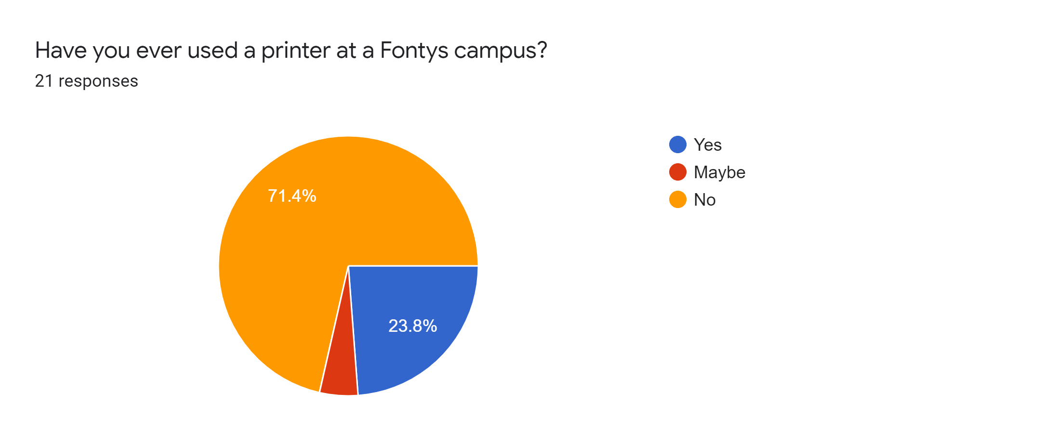

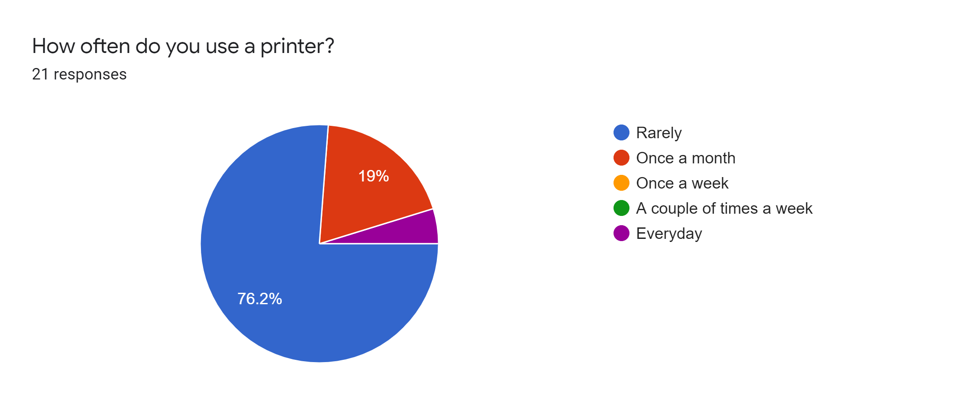

Out of 21 people we sent the survey to, we found out that students who don’t own a printer at their home are almost twice the number of students who own one. Most students use a printer rarely or once a month and only 23% (5 people) have used a printer at Fontys. 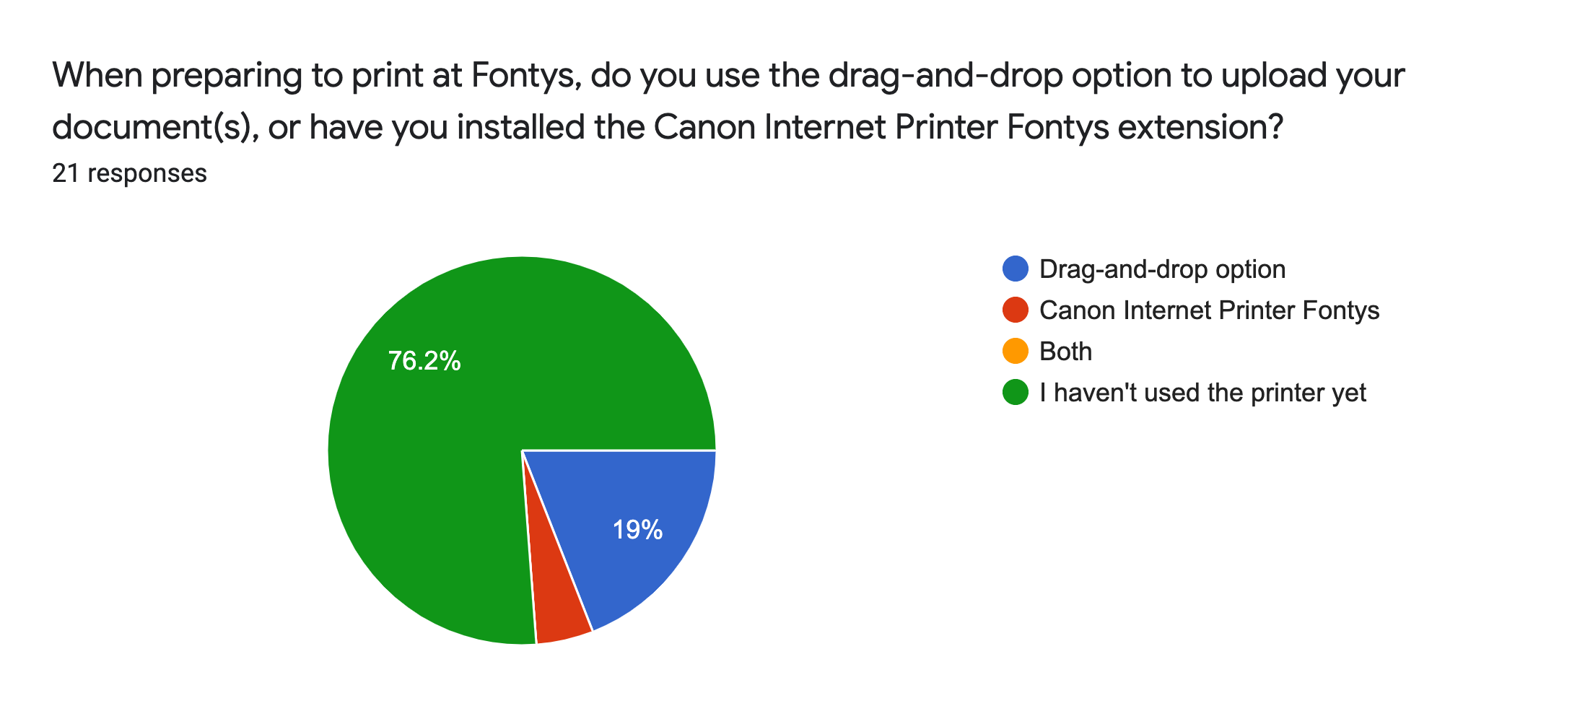

The drag-and-drop option in the Fontys website is the choice for 4 of the students who used the printers, while only 1 person has used the Canon Internet Printer Fontys extension.

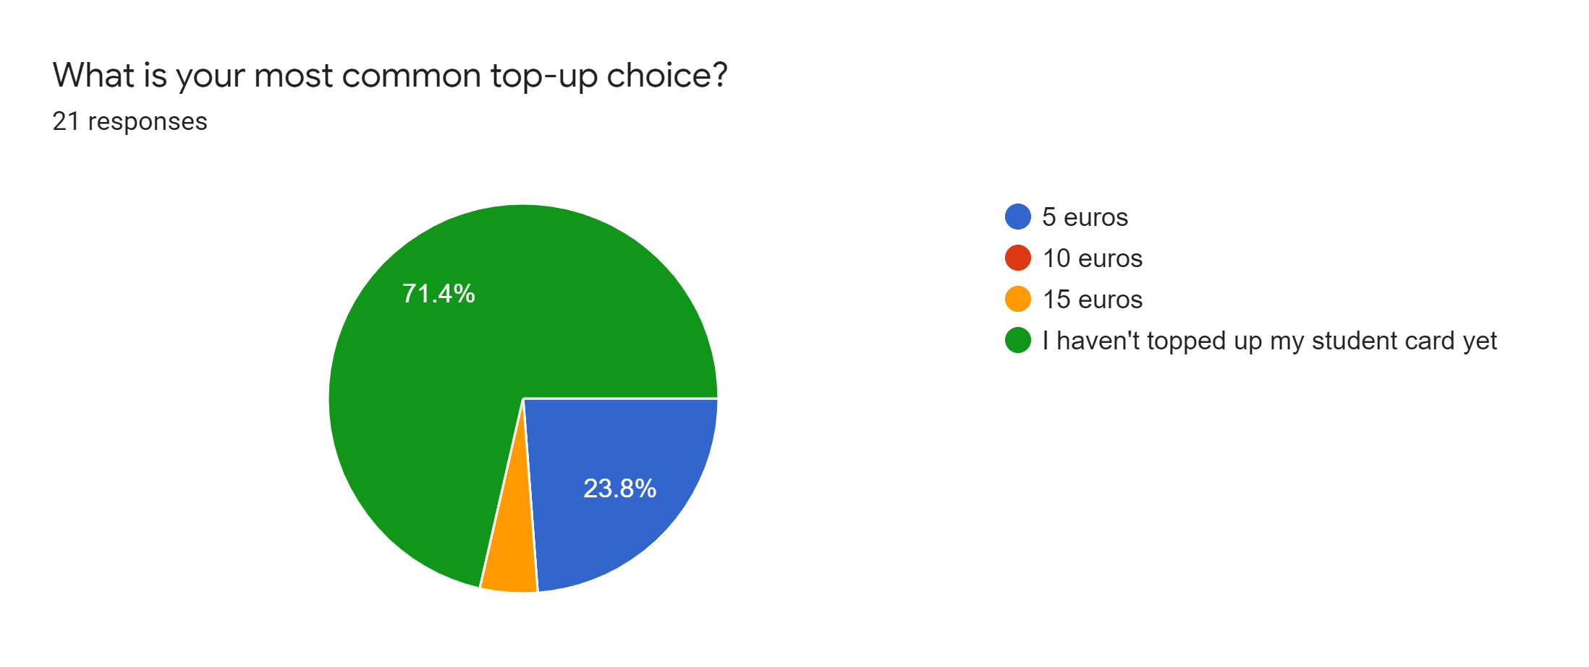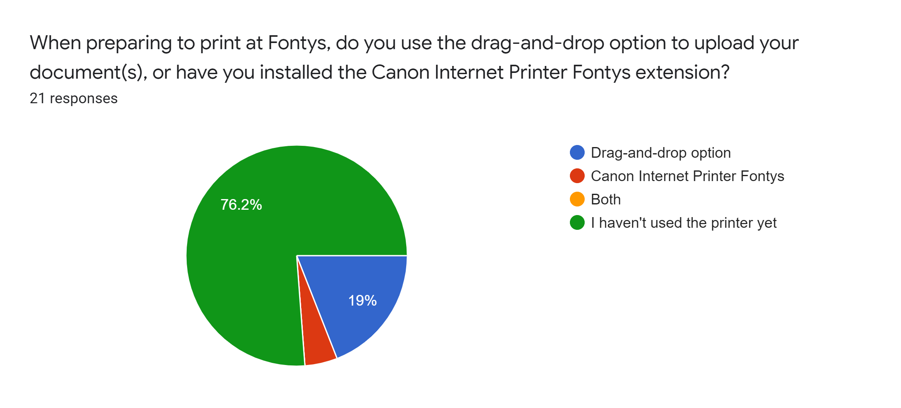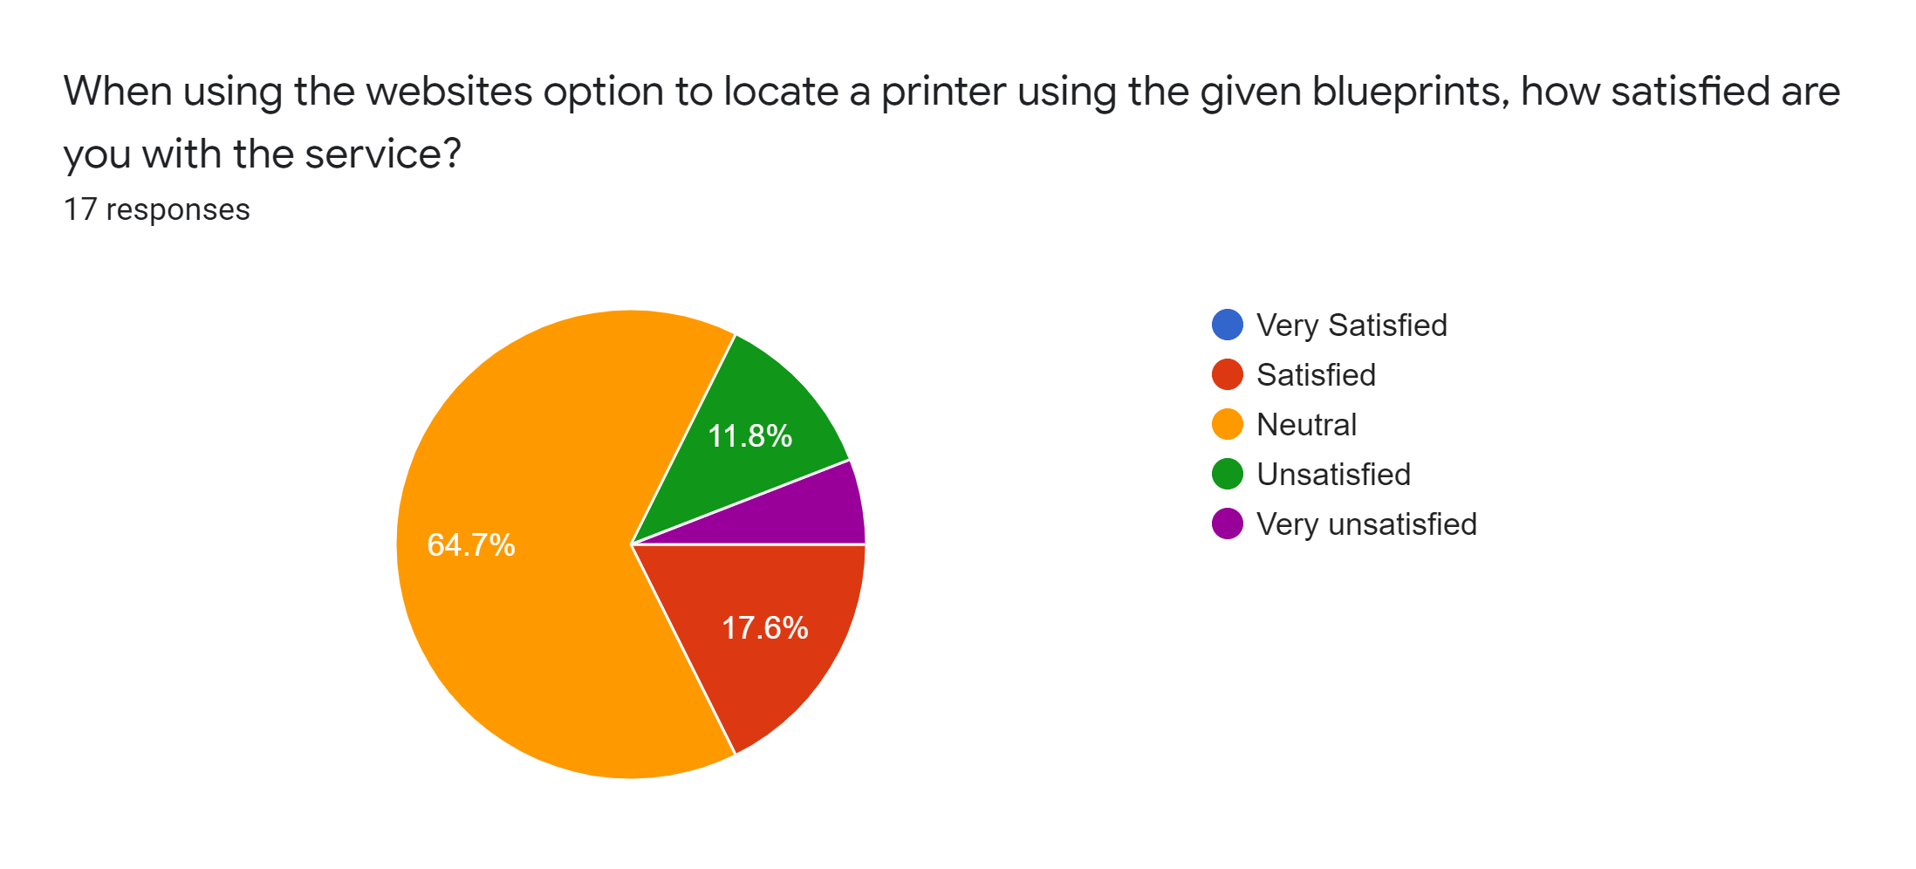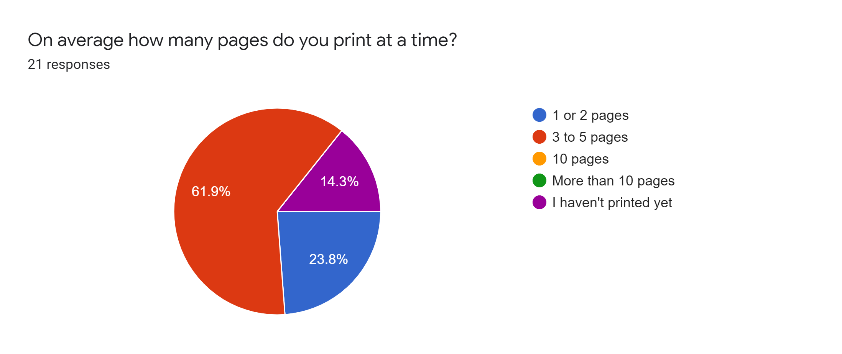

Most people say that they usually print 3 to 5 pages and the most common top-up option for students who have used the printer is €5. Almost everyone said they haven’t redeemed a voucher for their balance (19 people) with the exception of 2 students who don’t remember. Using the blueprints to locate printers is considered a Satisfying experience by 3 students, whereas 2 other students said that they find it Unsatisfying and only one - Very Unsatisfying.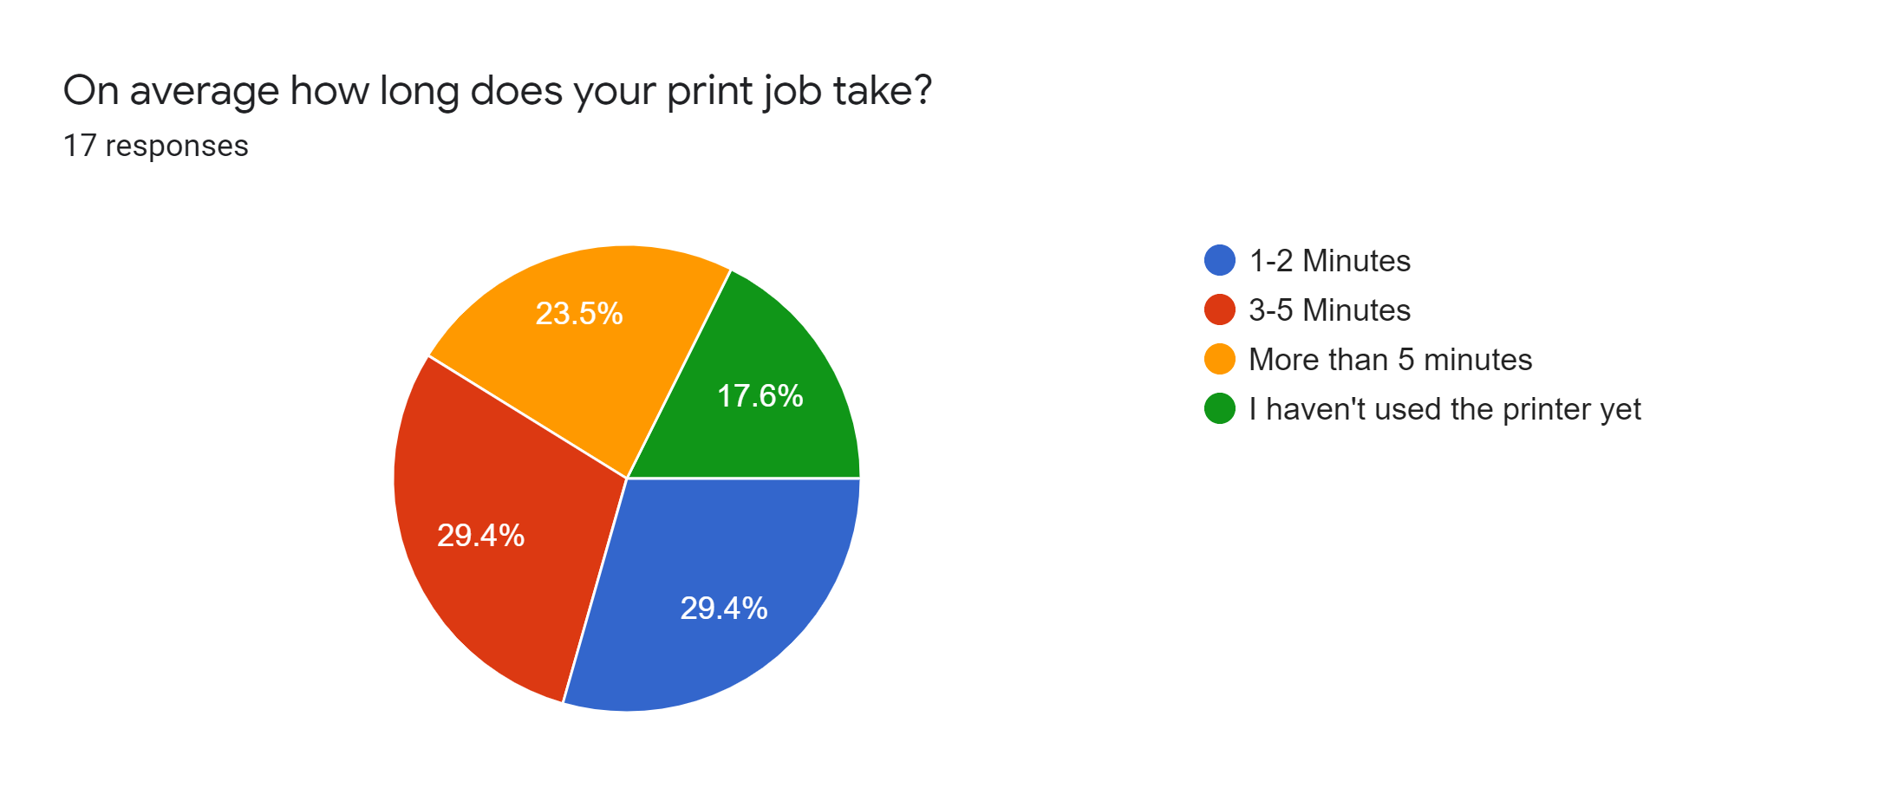

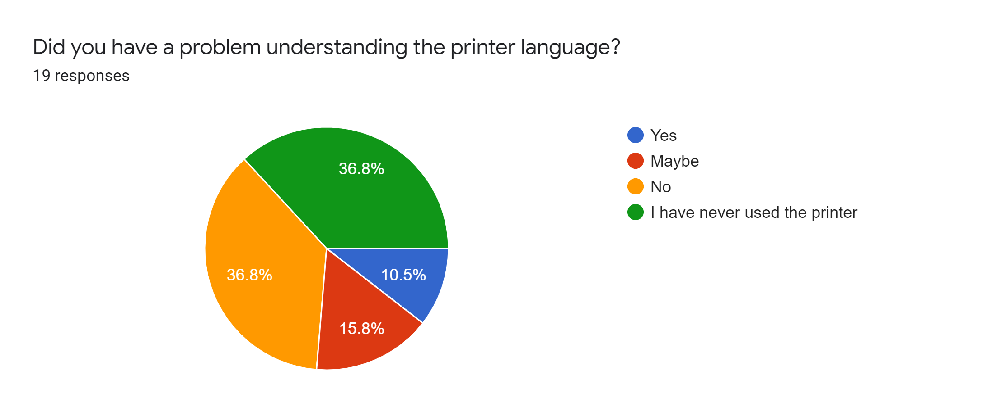

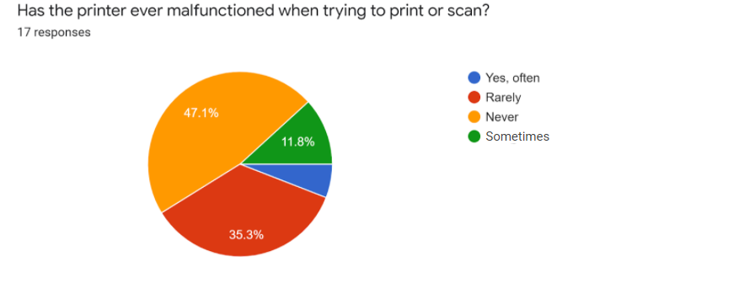

Most students who have used Fontys printers wrote that their average print job takes less than 5 minutes to complete and that they rarely experience problems while printing, with the exception of 2 students who had problems with the default language set on the printer.

**Conclusion**

To sum up, printers at the Fontys building are doing a decent job, but there are a few disadvantages that can be fixed. If these affairs were tended to, there would most likely only be positive feedback.

The most significant issues that have been mentioned by a couple of people, for one; is the trouble it takes to find said printers. It has resulted in many students going to the teachers to find out where the printers are. It could be said that this issue is what leads to so few students using the printers at Fontys. Another relevant point that should be considered is the language. It would be easier for most of the students if the printer’s language was preset in English. This would result in a more familiar configuration for most people. Finally, we come to the affair regarding the top-up options. It has been brought to our attention that the 5 euro top-up option may be too much for some people, and while the teachers may need to print hundreds of documents at a time, students for the most part only print a couple pages leaving a significant amount of money on their student card. We hope that you take our improvements regarding the printers at Fonty’s into consideration, and hopefully make the act of printing as effortless as can be expected.